Have you registered on the ProCare Rx member portal?
To register go to https://memberaccess.procarerx.com/
You will need you medical ID card to complete the information necessary to register.
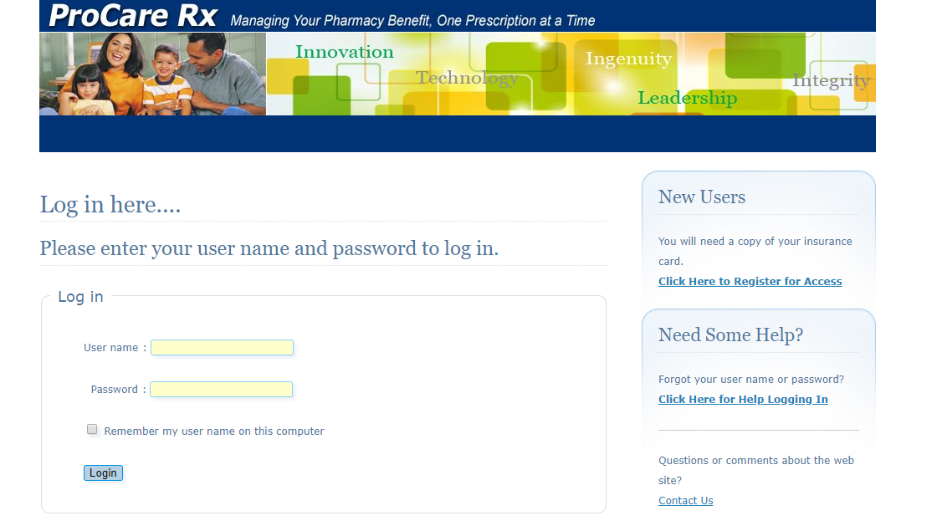
Click the Click Here to Register for Access

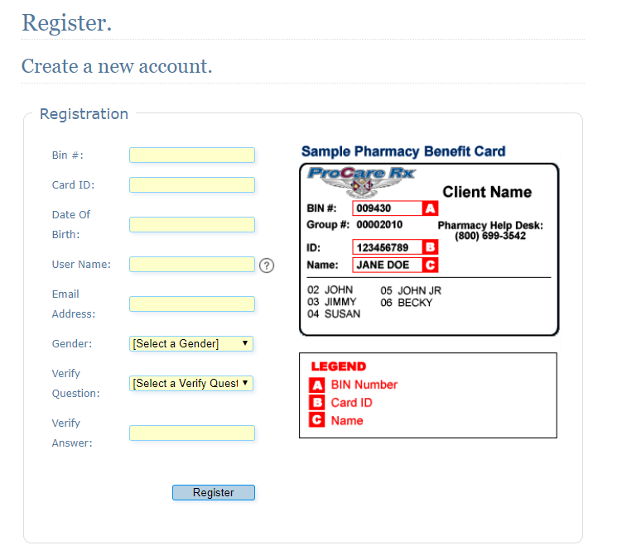
Please note: Please add EBMS in front of your EBMS member ID for your Card ID

