Understanding Your HDHP ID Card

FRONT:
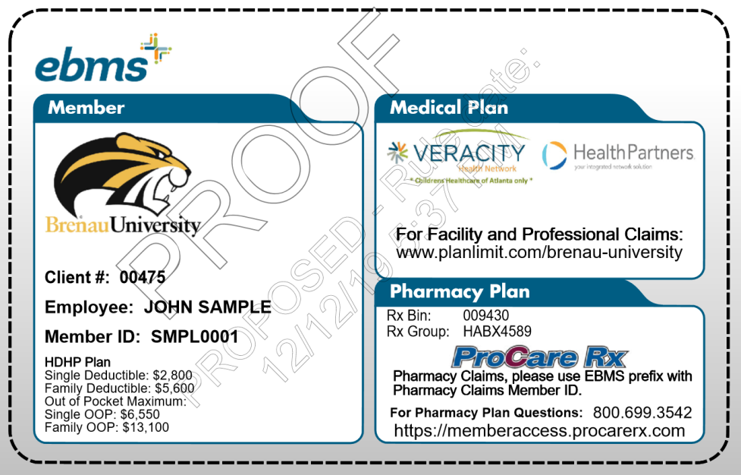
2
1
3

- Member Tab – The Member Tab is where you find all of your personal information. Please make sure this information is correct before using. The copays and deductibles will vary pending which plan you have elected.

- Medical Plan Tab – Medical Plan Tab – The Medical Plan Tab shows your access to health care providers. You have access to the Health Partners network in Gainesville. Their website is _________. You also have direct access to Childrens’ Healthcare of Atlanta (CHOA). Finally, any other healthcare providers can be accessed directly. “Planlimit.com/brenau-university” is the URL for ELAP Services for information on how their program works for your medical plan. It also provides contact information for members to call for assistance.

- Pharmacy Plan Tab - Your Pharmacy Benefit Manager (PBM) is listed here. Your PBM manages your prescription drug program. If you have questions about a particular drug, or questions about the program, please call the number listed.
NOTE: The Pharmacist must type in ebms as a prefix before entering in your member ID number.

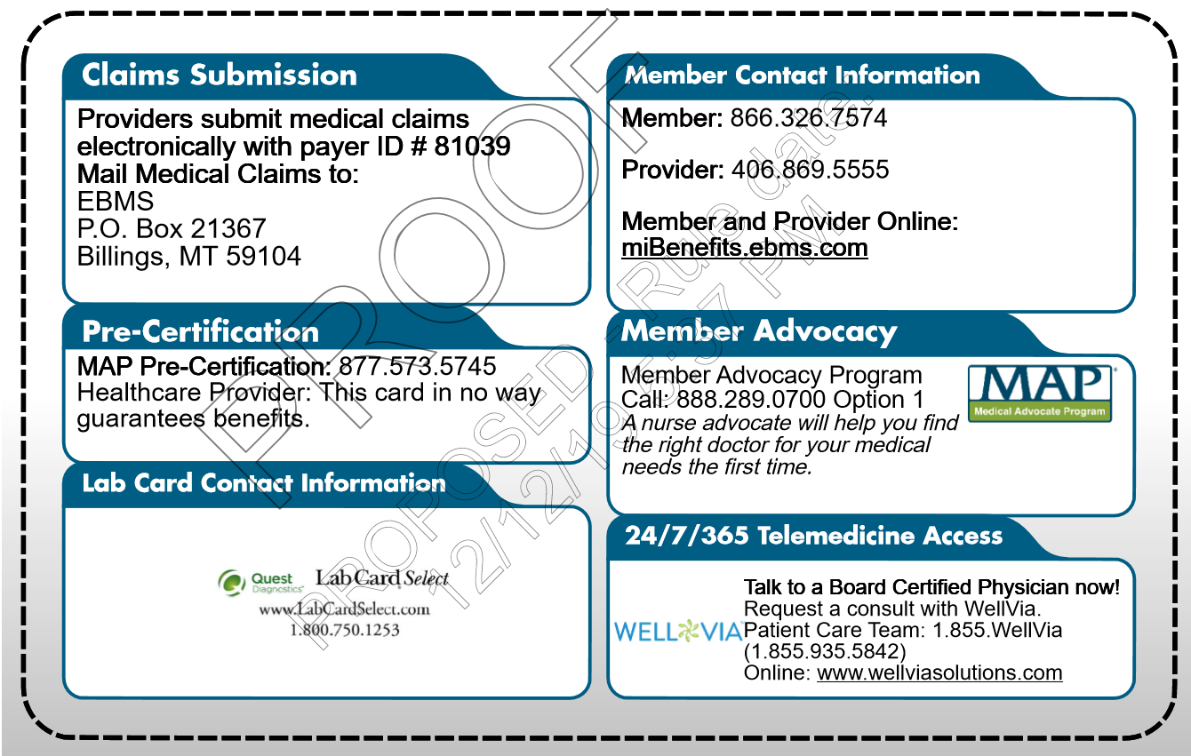
BACK:

1
4

2
5

3
6

- Claims Submission Tab – Providers will submit all claims to this address or electronically via the electronic ID number provided.

- Pre-certification Tab– Your provider will need to call this number in order to request authorization for a hospital stay or a surgical procedure.

- Lab Card Contact Information Tab – If you use Quest labs for your lab work, under the HDHP plan you will be asked to pay your deductible until satisfied and then any additional lab work will be free. Ask your physician if this is an option for you or use this information to find the closest location to you, to schedule an appointment, or to call with questions.

- Member & Provider Contacts Tab– Any Customer Service related questions should be directed to the Member Services number. This would include any questions you may have about your medical plan. Providers will use this number listed for benefit and eligibility verification.
- Member Advocacy Tab – This service can help you select a physician with the best outcomes and quality rating for the procedure that has been recommended to you. You can also call this number to find a physician or ask questions about any provider.

- Telemedicine – Wellvia is your 24 hours a day, 7 days a week, 365 days a year doctor on demand. Talk to a board certified physician anytime, and skip the lines at the doctor. Visit their online website for more information.

Understanding Your PPO ID Card
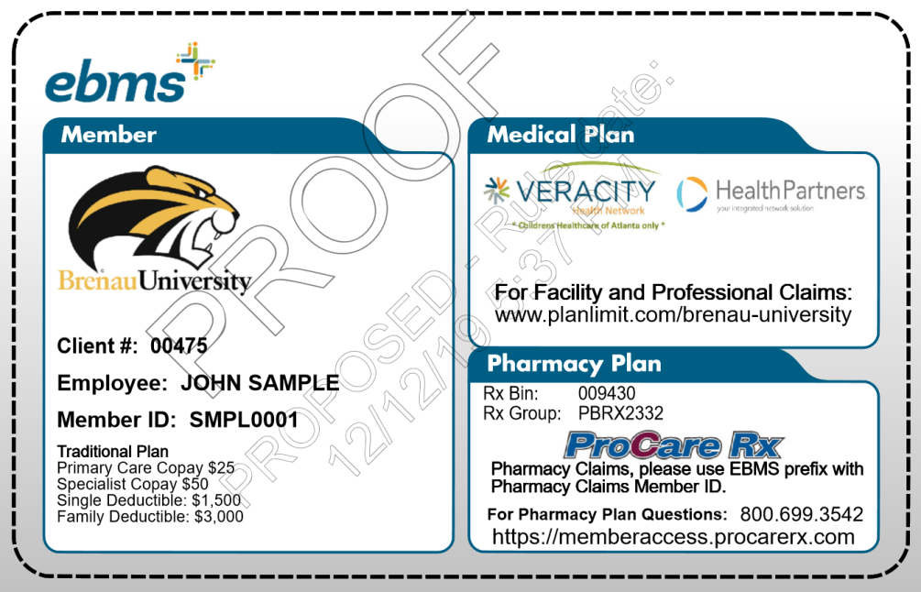
FRONT:

2
1
3

- Member Tab – The Member Tab is where you find all of your personal information. Please make sure this information is correct before using. The copays and deductibles will vary pending which plan you have elected.

- Medical Plan Tab – The Medical Plan Tab shows your access to health care providers. You have access to any health care providers through your plan. In addition, Brenau has direct contracts with these providers: 1) Health Partners network in Gainesville. Their website is http://www.healthpartnersnetwork.com/. 2) Childrens’ Healthcare of Atlanta (CHOA) and 3) Northeast Georgia Diagnostic Clinic. Any other healthcare providers can be accessed directly. “Planlimit.com/brenau-university” is the URL for ELAP Services for information on how their program works for your medical plan. It also provides contact information for members to call for assistance.

- Pharmacy Plan Tab - Your Pharmacy Benefit Manager (PBM) is listed here. Your PBM manages your prescription drug program. If you have questions about a particular drug, or questions about the program, please call the number listed.
NOTE: The Pharmacist must type in ebms as a prefix before entering in your member ID number.

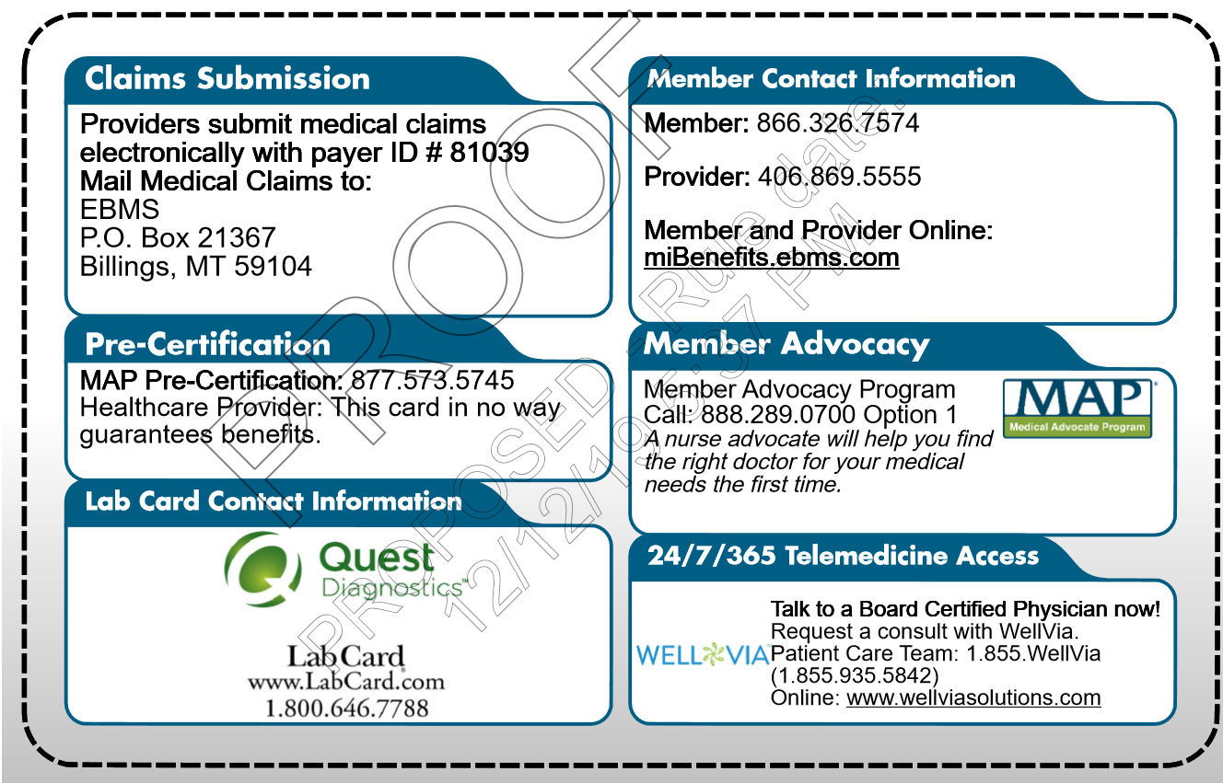
BACK:
1
4

5
2
3
6

- Claims Submission Tab – Providers will submit all claims to this address or electronically via the electronic ID number provided.

- Pre-certification Tab– Your provider will need to call this number in order to request authorization for a hospital stay or a surgical procedure.

- Lab Card Contact Information Tab – If you use Quest labs for your lab work, you will
have no cost sharing, i.e. the lab work will be free to you. Ask your physician if this is an
option for you or use this information to find the closest location to you, to schedule an
appointment, or to call with questions.

- Member & Provider Contacts Tab– Any Customer Service related questions should be directed to the Member Services number. This would include any questions you may have about your medical plan. Providers will use this number listed for benefit and eligibility verification.

- Member Advocacy Tab – This service can help you select a physician with the best outcomes and quality rating for the procedure that has been recommended to you. You
can also call this number to find a physician or ask questions about any provider.

- Telemedicine – Wellvia is your 24 hours a day, 7 days a week, 365 days a year doctor on demand. Talk to a board certified physician anytime, and skip the lines at the doctor. Visit their online website for more information.

