Brenau Workshop for Faculty, Adjuncts, and Staff

Tuesday, March 27th
Creating a Culture of Integrity

Via Zoom:
Byron P. McCrae, Ph.D.
Vice President for Student Life & Dean of Students
from
Davidson College
Davidson, NC
Time: 12:30-1:45 PM (Lunch ends at 12:45 PM)

Location: Trustee Library Rm #116 or via ZOOM

RSVP Link:
RSVP using this Google Form

Zoom Meeting ID: 231726223

Zoom Access Information
Join from PC, Mac, Linux, iOS or Android: https://brenau.zoom.us/j/231726223

Or Telephone:

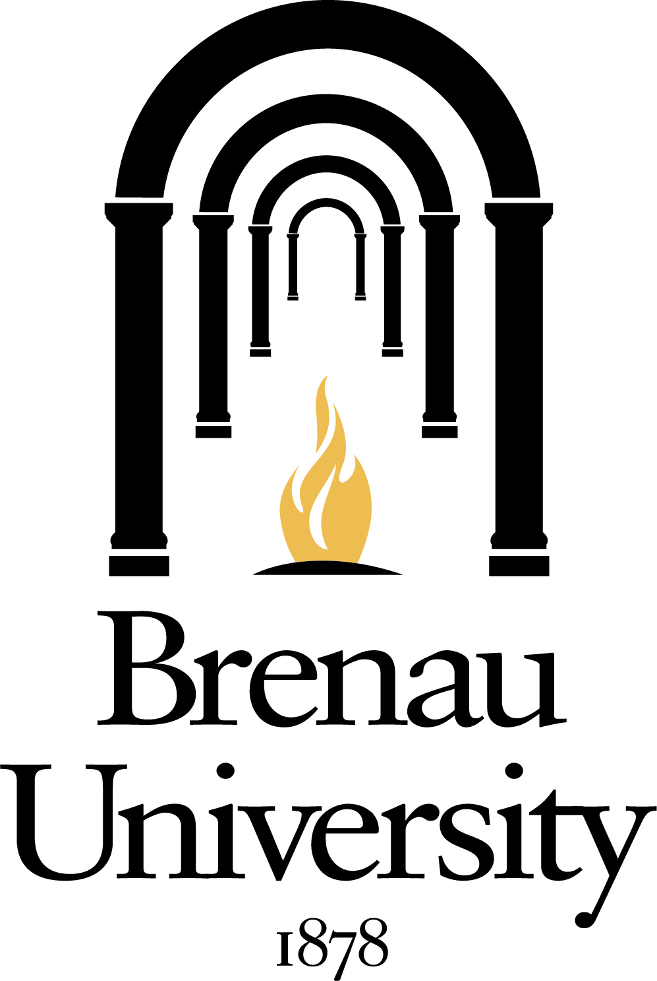
Dial(for higher quality, dial a number based on your current location):
US: +1 669 900 6833 or +1 408 638 0968 or +1 646 876 9923
Meeting ID: 231 726 223
